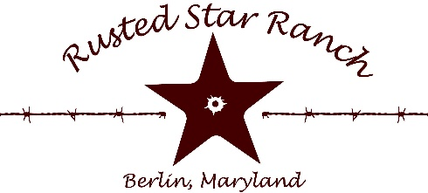
Rusted Star Ranch (RSR) is a small, but busy western performance barn specializing in cowboy mounted shooting located in Berlin, Maryland. Horsemanship is a major focus in working with RSR horses. This position is an excellent opportunity for an individual to work underneath a CMSA Professional Horseman and with horsemen who are national level competitors.
Position: RSR Working Student
Salary: Unpaid
Duties include:
- Feeding, haying, watering horses both in stalls and pastures
- Picking and preparing stalls
- Grooming and tacking up horses for trainer
- Basic farm chores including (but not limited to) sweeping, operating a four-wheeler, leaf blower, small tractor, etc.
- Lunging horses
- Basic equine health care
Schedule:
3 days per week Evenings 3 hrs daily
Duration of Position:
3 - 4 months (possible extension)
Required:
- Horse or large livestock experience
- Self-Motivated, Dependable
- Ability to work in a wide range of weather conditions
- Friendly personality when interacting with farm clientele
- Provide own health insurance and transportation
- Wear closed toe shoes while at work
- Complete farm waiver and emergency contact form
By signing below, I acknowledge that I will be working on a farm and accept the expectations and requirements of myself as a working student.
___________________________________ _______________________________
Printed name Signature

___________________________________ ________________________________
Guardian (if under 18 years old) printed name Signature

___________________________________ ________________________________
Farm Owner Signature

